PMP Year 1 Term 2 Test 2 Tryhub Marta PMI-16 Option I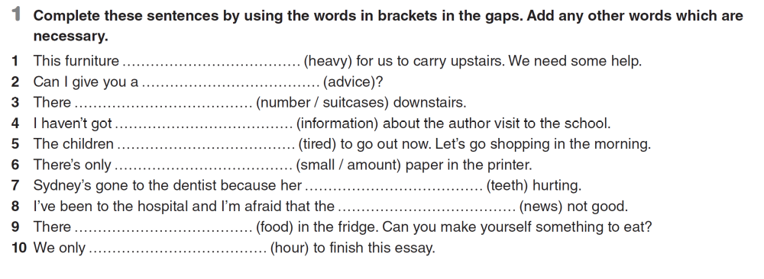
1.
- This furniture is too heavy for us to carry upstairs. We need some help.
- Can I give you a piece of advice?
- There are a number of suitcases downstairs.
- I haven't got any information about the author's visit to the school.
- The children are too tired to go out now. Let's go shopping in the morning.
- There's only a small amount of paper in the printer.
- Sydney's gone to the dentist because her teeth are hurting.
- I've been to the hospital and I'm afraid that the news is not good.
- There is some food in the fridge. Can you make yourself something to eat?
- We only have one hour to finish this essay.

2. Complete the gaps with a\an, the or no article:
1. I was at ……….cinema yesterday.
a) a b) the c) no article
2. How often do you go for ……….walk?
a) a b) an c) the
3. What did you have for ……….lunch at school?
a) no article b) the c) a
4. Today is ……….10th of May.
a) no article b) a c) the
5. She comes from ………..UK.
a) no article b) an c) the
6. ……….Andes are in Latin America.
a) the b) an c) no article
7. The longest river in the world is ………Nile.
a) the b) a c) no article
8. The collapse of……….Soviet Union was in 1991.
a) the b) a c) no article
9. I’d like to visit ……….South America.
a) a b) the c) no article
10. I saw ………children playing in the yard.
a) a b) an c) no article

3. Complete the sentences
1. If your conditions are competitive, we (place) will place an order.
2. If I had more time, I (do) would do a course in legal English.
3. If we had known more about their culture, negotiating (be) would have been more successful.
4. If you (enhance) enhance your CV, your chances of getting a job will be higher.
5. We (cancel) will cancel our order if you don't deliver the goods by Monday.
6. If Larisa (speak) spoke better English, she would apply for a job abroad.
7. If you (tell) had told me about the situation, I would have helped you.

4. Translate into English:

- Ви не можете піти поки не розкажете правду.

You can`t leave without telling the truth.

- Якби вона не була хвора, ми б пішли на дискотеку.

If she wasn't sick, we would have gone to the disco.

- Він говорив пошепки, наче боявся щоб його почули.
He was whispering as if he was afraid of being heard.

